Assignment 1 - Node Modules, Express, MongoDB and REST API

Instructions
In this assignment you will continue the exploration of Node modules, Express, MongoDB and the REST API.
Assignment Overview
At the end of this assignment, you should have completed the following tasks to update the server:
- Applied MVC pattern
- Created a Node module using Express router to support the routes for the dishes REST API.
- Created a Node module using Express router to support the routes for quizzes and questions REST API.
- Created mongoose model
- Connected with MongoDB
Assignment Requirements
+ A simple quiz is an interactive application designed to test users' knowledge on a particular topic or subject. It typically consists of a series of questions with multiple-choice options. Users select their answers and at the end of the quiz, the app displays the user's score and often offers a review of the questions and their correct answers.
+ Build your backend project that manages quiz and questions for a simple quiz app. The app allows users to implement the REST API (GET, POST, PUT, DELETE) endpoints /quizzes, / quizzes/:quizId and /question, /question/:questionId to interact with the MongoDB database namly SimpleQuiz.
+ Student can write the code based on the specific tasks
1. Create the schemas basing on the all requirements as below
Quiz: Represents a quiz or a test.
- Object_id: Unique identifier for the quiz.
- title: Title or name of the quiz.
- description: Description or instructions for the quiz.
- questions: An array of question IDs associated with the quiz.
Question: Represents a single question in the quiz.
- Object_id: Unique identifier for the question.
- text: The text of the question.
- options: An array of answer options for the question.
- keywords: An array of keywords for the question.
- correctAnswerIndex: Index of the correct answer within the options array.
2. Do the REST API (GET, POST, PUT, DELETE) endpoints /quizzes, /quizzes/:quizId and /question, /question/:questionId are implemented to interact with the MongoDB database namely SimpleQuiz
Note: using Mongoose populate in order to display all questions in quiz when do endpoint /quizzes
route GET/quizzes
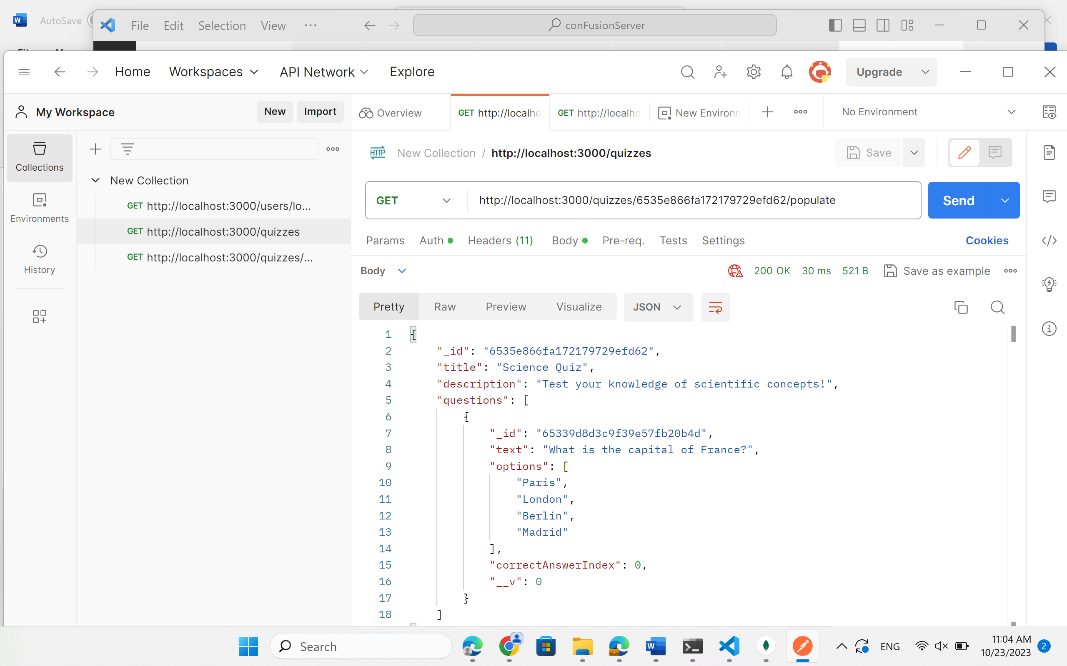
Run chạy route POST/questions
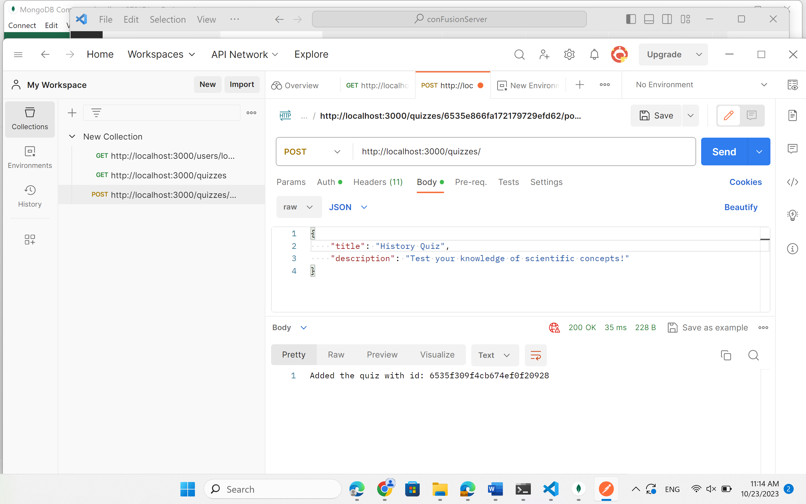

Run chạy route DELETE/quizzes/:id
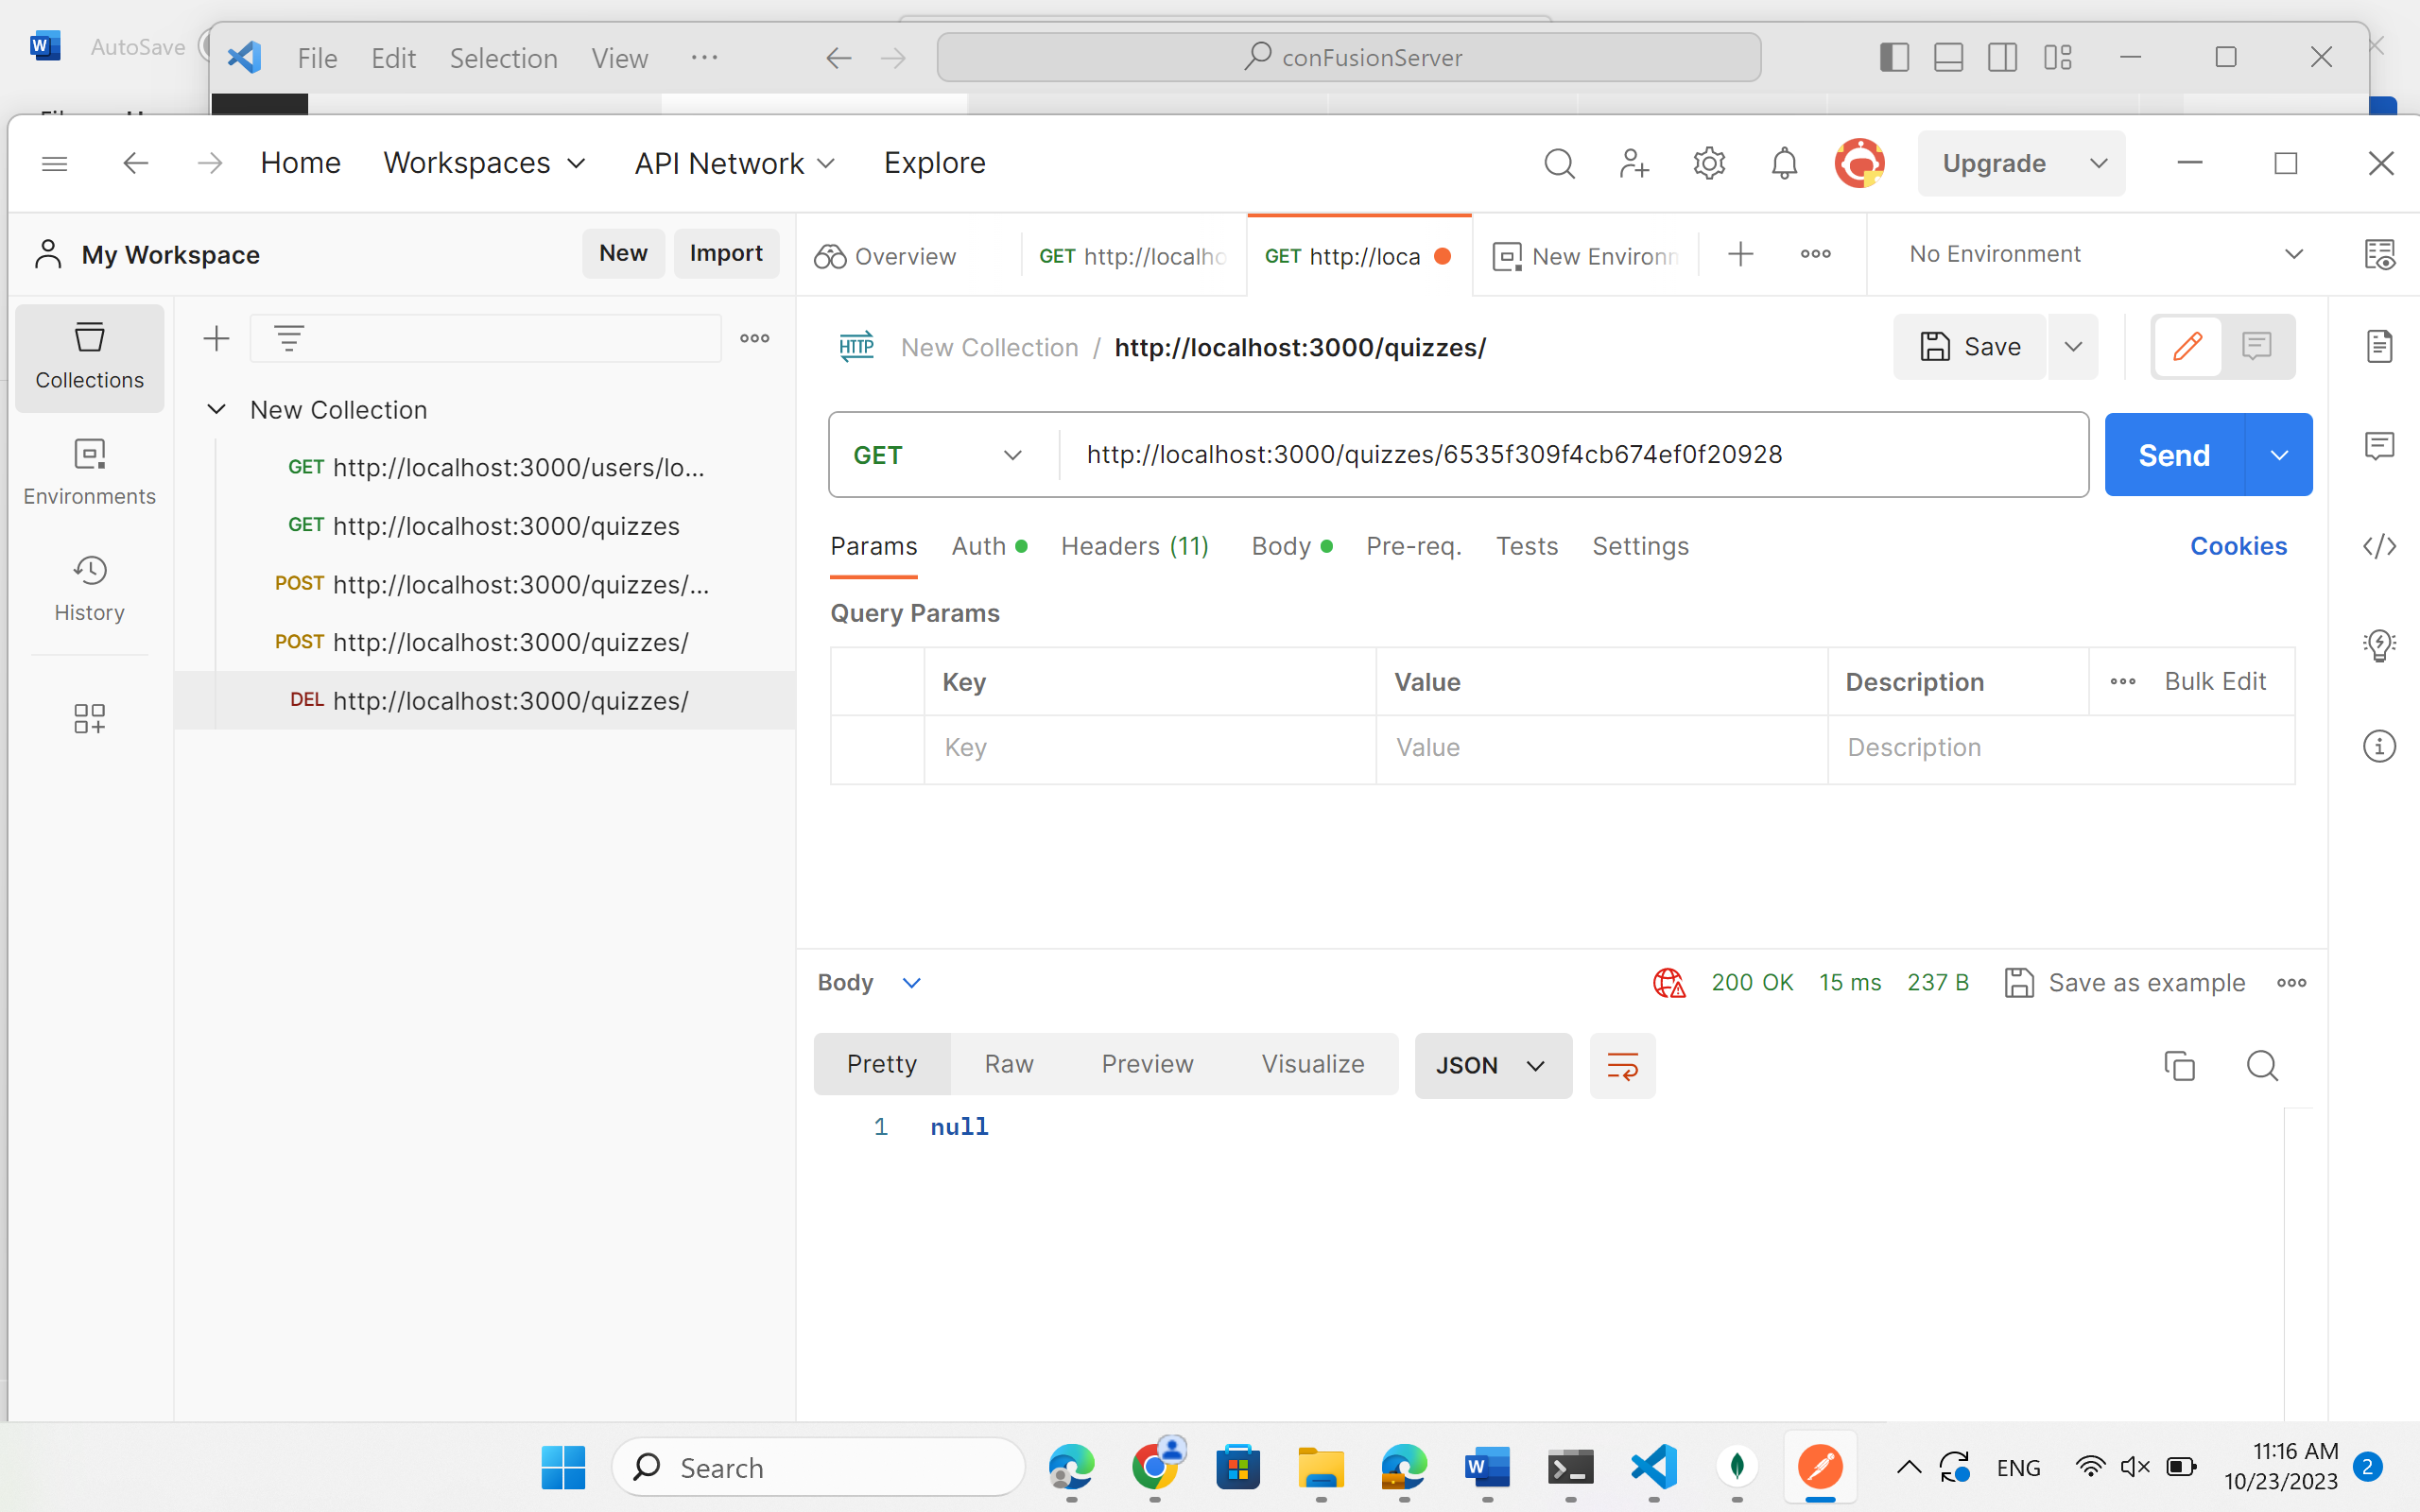

3. Do the REST API (GET) endpoints /quizzes/:quizId/populate to match all questions with the word "capital"
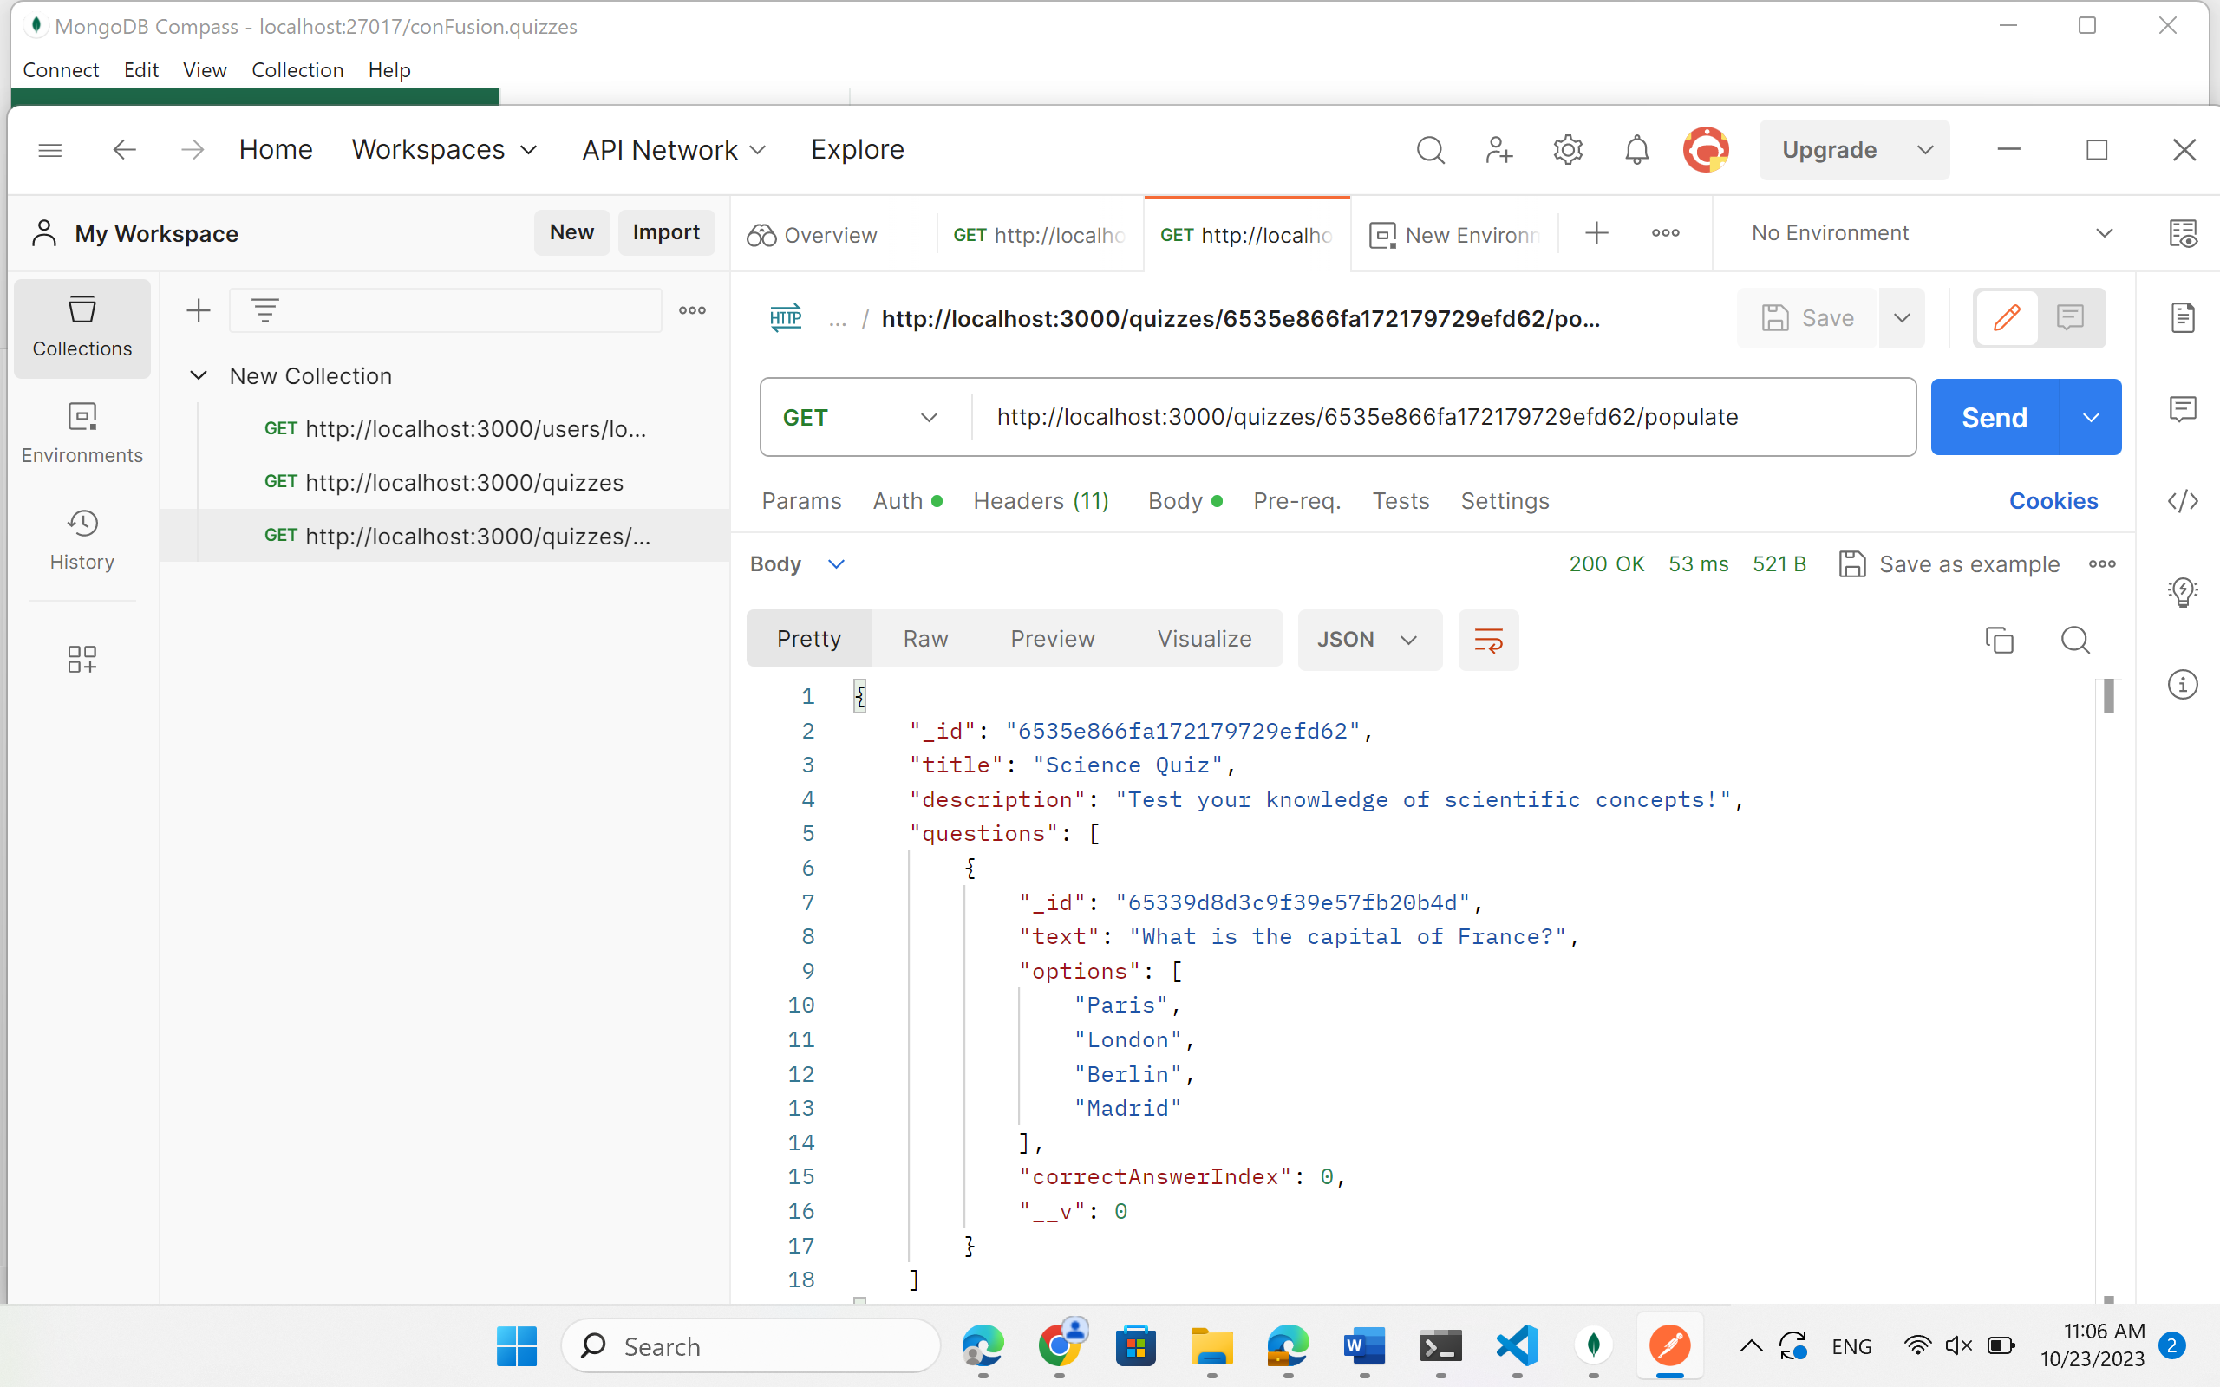
4. Do the REST API (POST) endpoints /quizzes/:quizId/question to create new question in quizId
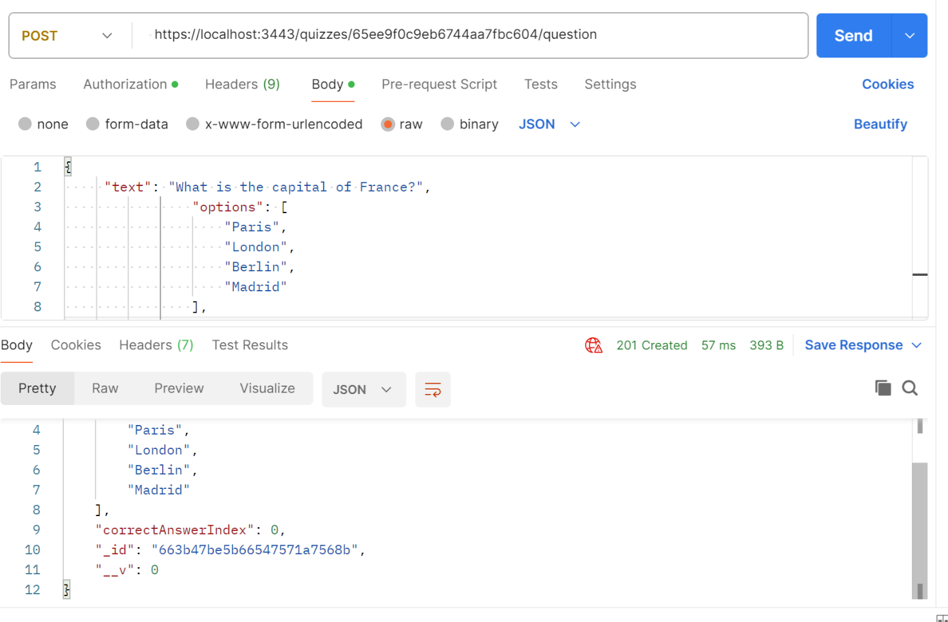
5. Do the REST API (POST) endpoints /quizzes/:quizId/questions to create many new questions in quizId
